SAMSON EUNICE

WRITER · BRAND IDENTITY STRATEGIST · CREATIVE CONCEPT ARCHITECT · PUBLISHER · BUSINESS DEVELOPER

Some people see an idea. I see what it could become.

01 — THE INTRODUCTION

I HAVE ALWAYS BEEN A HATER OF MEDIOCRITY.

Not because everything has to be perfect.

But because I believe that when you decide to build something, it should carry the evidence of thought.

An idea deserves more than execution.

It deserves identity.
It deserves direction.
It deserves a reason to exist.

And that is where I come in.

I work with ideas at the point where creativity meets strategy.

I look beyond what something currently is to understand what it could become, what it should communicate, how it should be perceived, and what needs to exist around it for that vision to become tangible.

As an Identity Strategist and Creative Concept Architect, I don't simply help people make things look or sound better.

I help them think through what they are building.

Because sometimes, the problem isn't that the idea is bad.

The problem is that the idea has no identity.

No structure.

No language.

No system.

No distinct point of view.

And without those things, even a brilliant idea can become indistinguishable from everything else.

My work therefore sits between concept, identity, communication and execution.

I use writing to articulate ideas.

Strategy to give them direction.

Storytelling to give them meaning.

Systems to give them structure.

And creativity to make them impossible to confuse with the ordinary.

I don't believe in building for the sake of building.

I believe in building something that knows exactly why it exists.

EXPLORE MY WORK

02 — THE BODY OF WORK

A BODY OF WORK, NOT A LIST OF TITLES.

My work has moved across different industries, formats and environments, but the underlying question has remained consistent: How do we turn an idea into something people can understand, recognise and remember?

WRITING

Creative Writing · Copywriting · Songwriting · Storytelling · Scripts · Content Writing · Ghostwriting · Blog Writing · Brand Writing · Email & Newsletter Writing · Official Writing · Academic Writing

IDENTITY & BRANDS

Brand Communication · Brand Positioning · Messaging · Concept Development · Strategic Storytelling · Personal Branding · Content Strategy

PUBLISHING

Authorship · Book Development · Proofreading · Editing · Manuscript Development · Publication

EDUCATION

Creative Writing · Copywriting · Communication · Storytelling · Workshops · Masterclasses · Coaching · Mentorship

COMMUNITIES

Community Development · Opportunity Systems · Programming · Communication · Member Engagement

BUSINESS

Business Development · Partnerships · Strategic Communication · Growth Initiatives · Opportunity Development

EVENTS

Event Operations · Stakeholder Communication · Partnership Support · Facilitation · Coordination

03 — THE NUMBERS

THE WORK, IN NUMBERS.

500+
People trained in creative writing

3 Books authored and published

6 Global opportunities curated daily through Vertex

MULTIPLE

Creative, editorial, educational, community and business projects

04 — THE JOURNEY

THE WORK EVOLVED. THE QUESTION REMAINED.

I started with writing.

Writing taught me how ideas become language.

Language led me into storytelling.

Storytelling taught me how people connect with meaning.

That led to publishing, where ideas had to become tangible.

Then came education, where I began helping other people find their own voice and communicate their ideas.

From there, I moved deeper into brands, identity and communication, asking not only what should be said, but what a person, product or organisation should be known for.

Building communities introduced me to systems, people and opportunity.

And business development expanded that thinking into relationships, partnerships and growth.

Songwriting is another expression of that same creative instinct: using words, emotion and narrative to create something people can feel and remember.

Today, these aren't separate chapters to me.

They are connected disciplines.

I write. I strategise. I build. I teach. I publish. I develop.

And somewhere between all of them, I found the work I was actually meant to be doing:

Turning ideas into concepts with identity, direction and possibility.

05 — SELECTED WORK

SELECTED WORK

Not everything I've done belongs here.

Only the work that tells you something about how I think.

PASSION
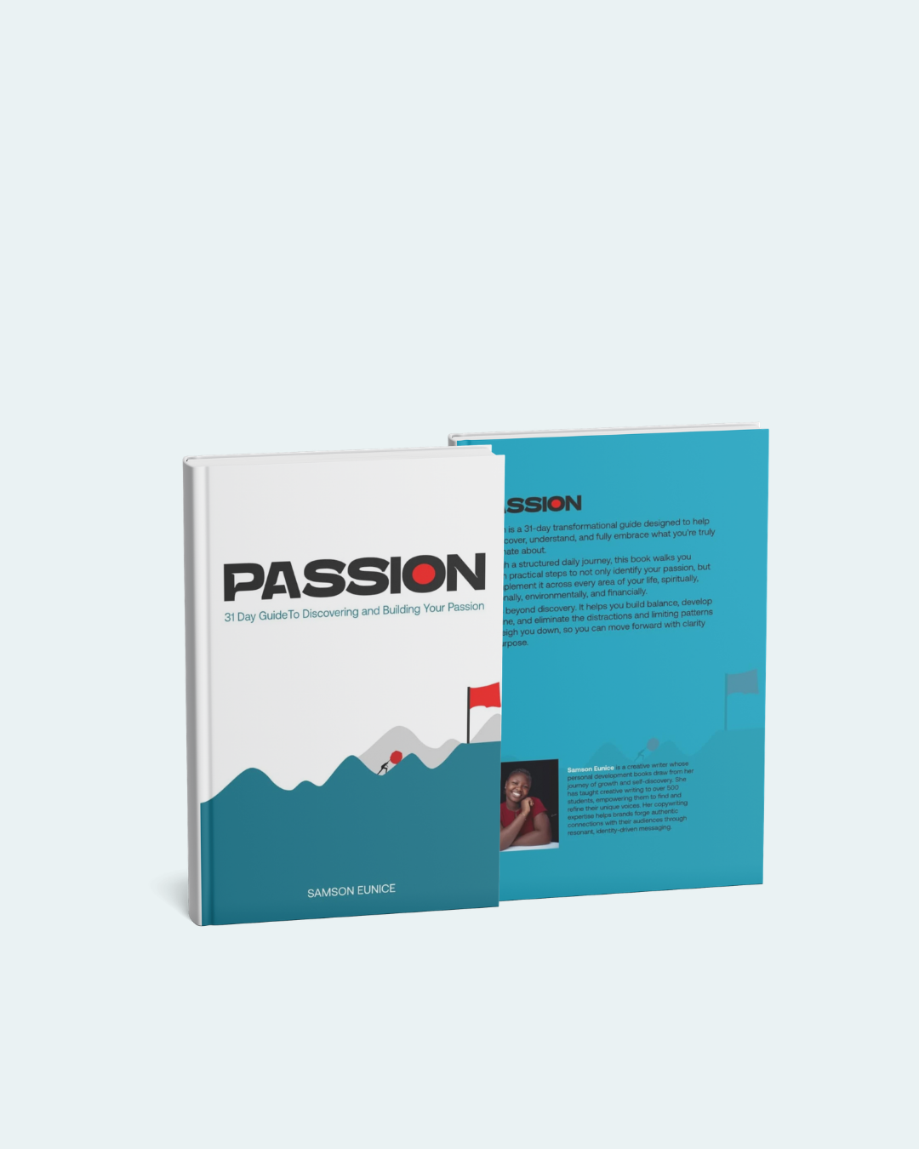

Author · Publisher (Samson Eunice)

A 30-Day Guide to Knowing Your Passion and Building It.

An authored and physically published book exploring passion not simply as something to discover, but something to understand, develop and build.

Writing · Concept Development · Publishing · Launch

REMOTE GROWTH BLUEPRINT
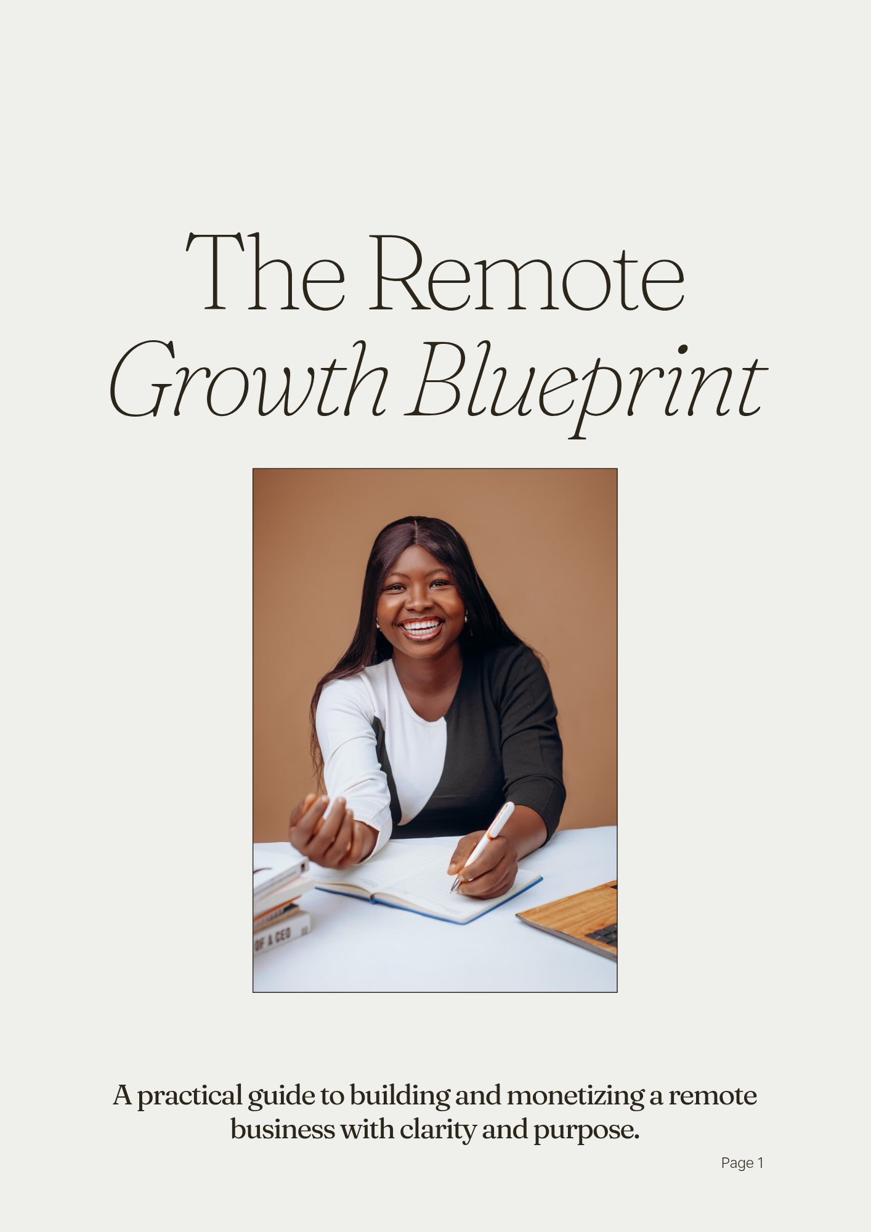

Author · Digital Product Creator (Samson Eunice)

A digital resource developed around navigating remote work, opportunities and professional growth.

Research · Writing · Product Development · Communication

VERTEX COMMUNITY

Community Development · Strategy

A community built around access to remote opportunities, scholarships, learning, networking and professional growth.

The work extends beyond creating a community. It involves thinking through how information is discovered, verified, structured and delivered consistently enough to become useful.

Community Strategy · Opportunity Curation · Communication · Systems

COMMUNICATE YOUR BRAND
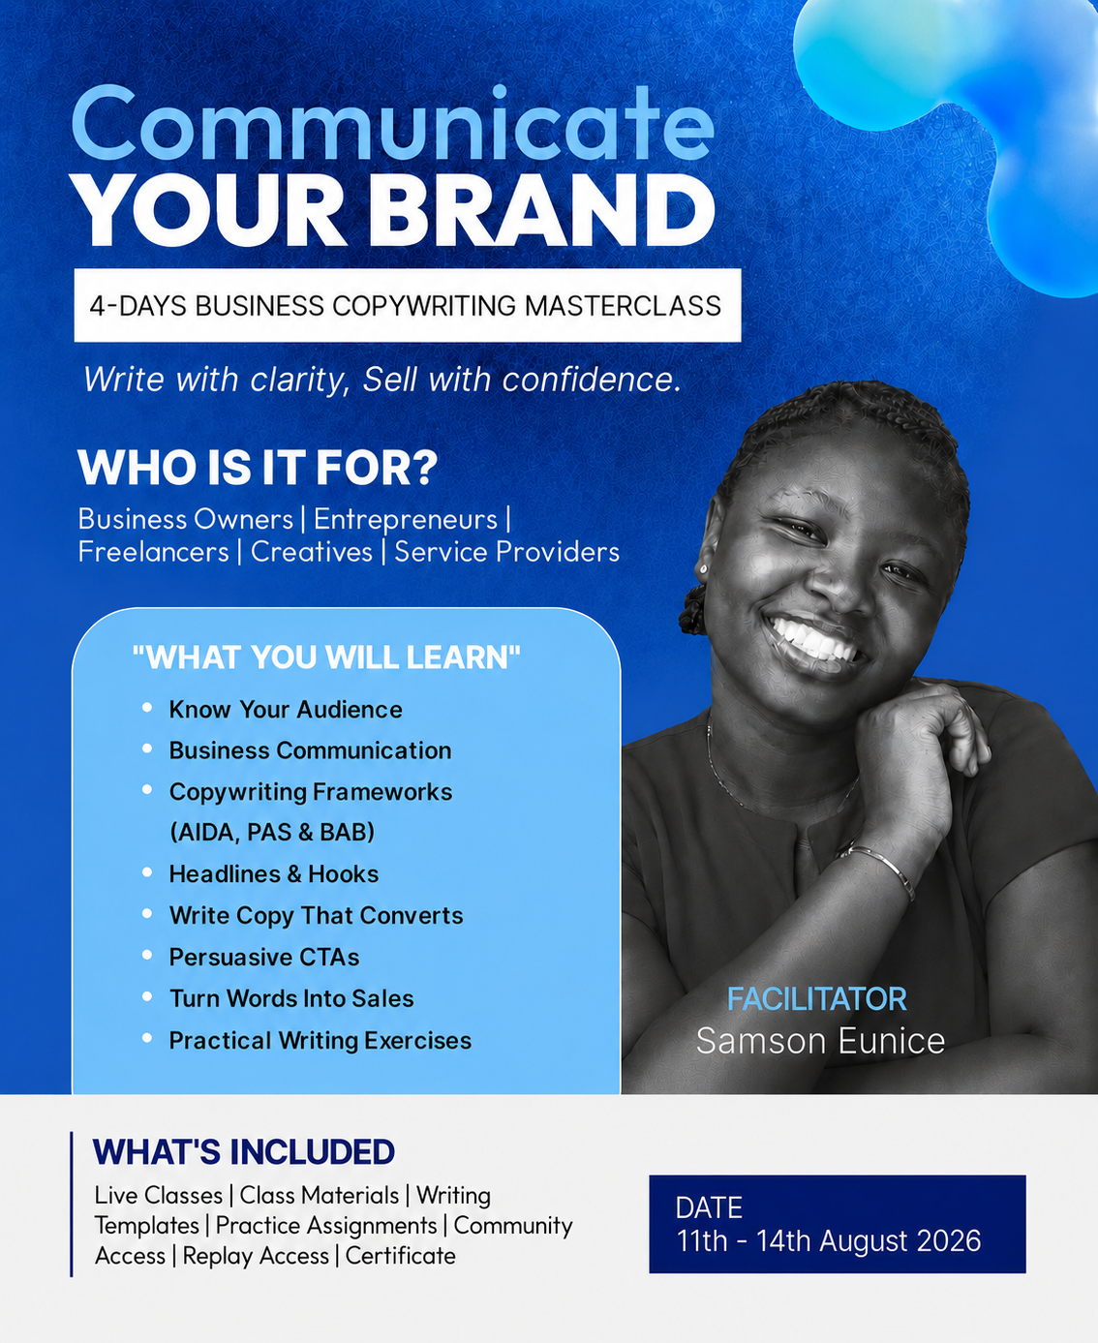

Creative Direction · Curriculum · Facilitation

A practical business copywriting masterclass designed around a simple problem:

People may have something valuable to offer, but still struggle to communicate why it matters.

The programme translates copywriting, storytelling, audience psychology and brand communication into practical learning.

Curriculum Development · Copywriting · Brand Communication · Facilitation

RESULTS: 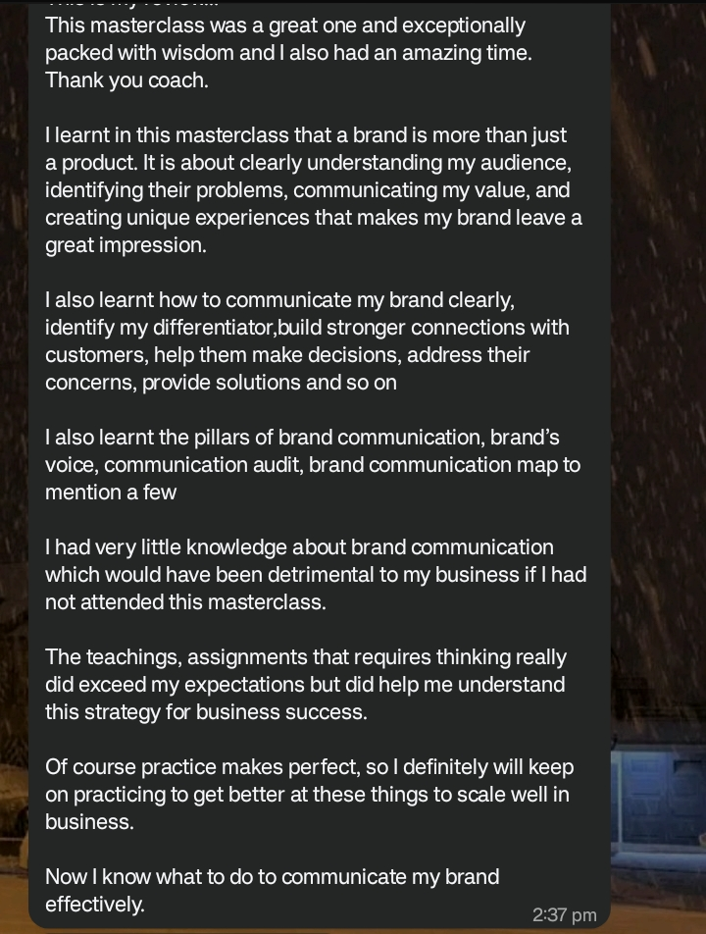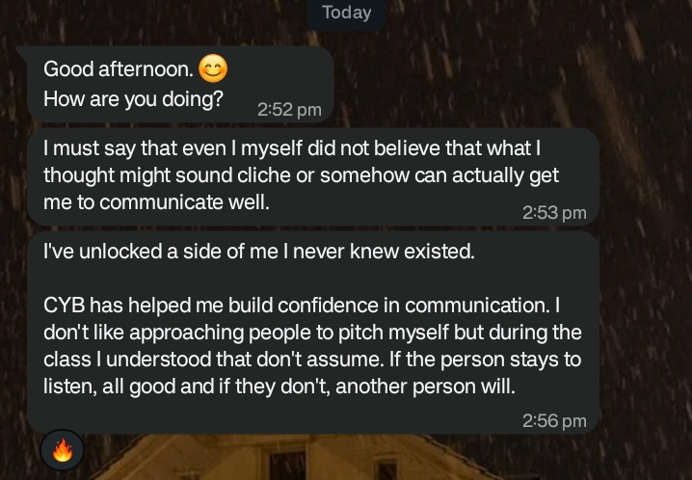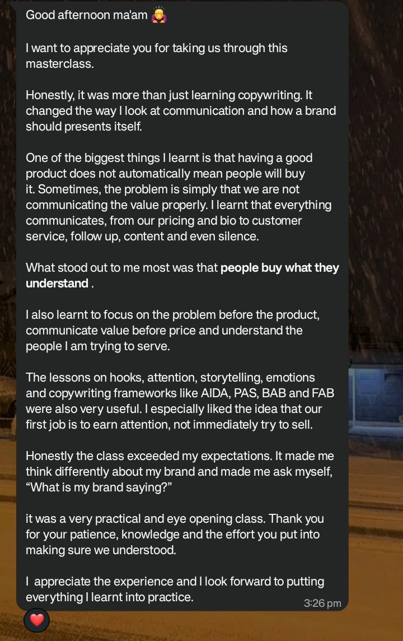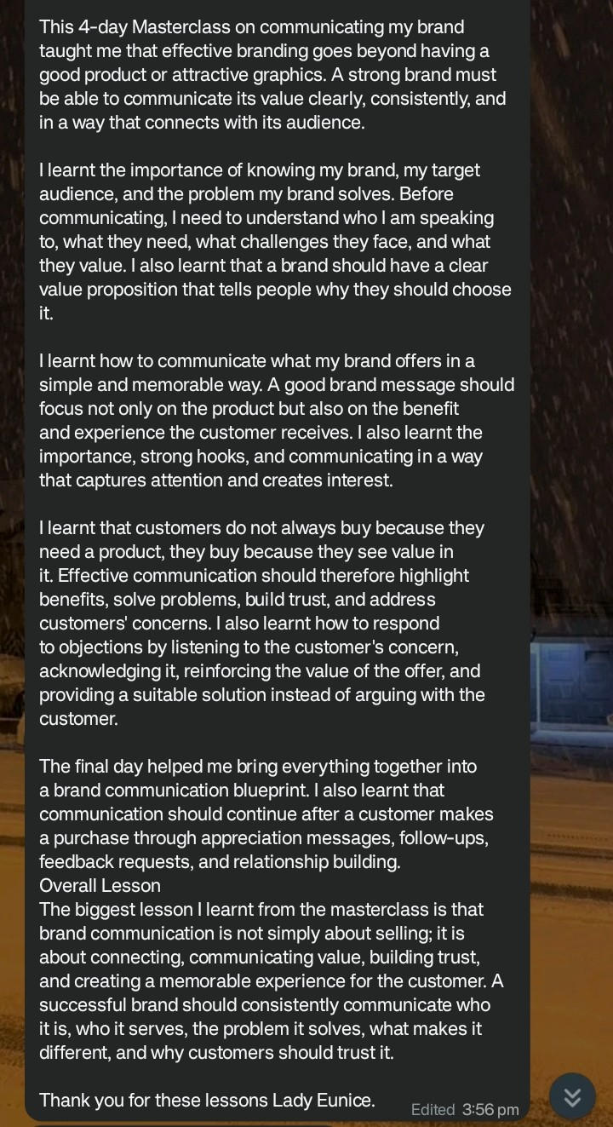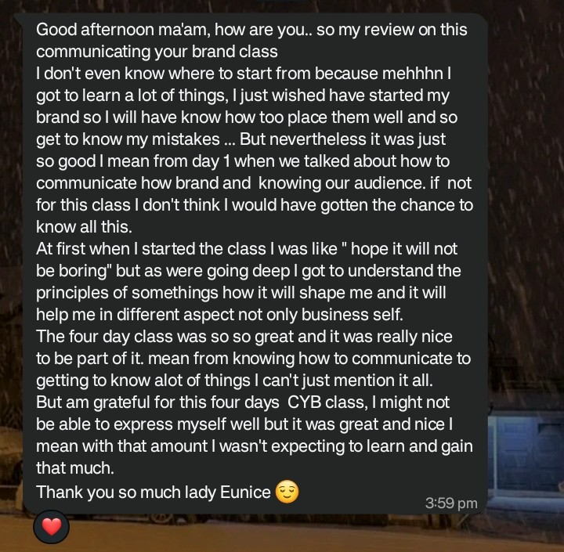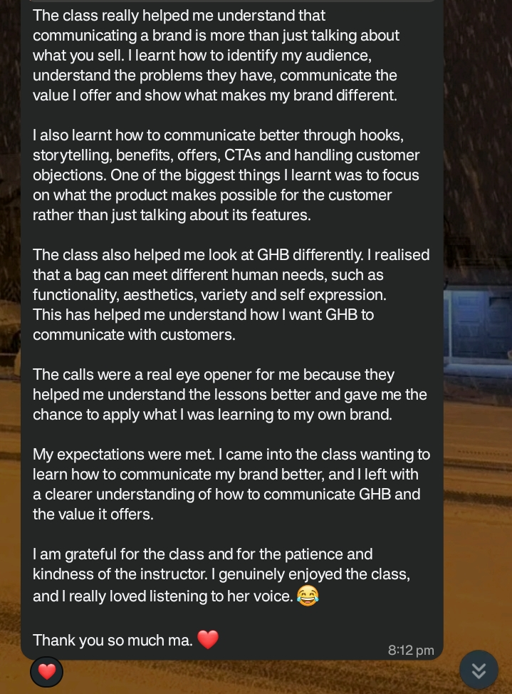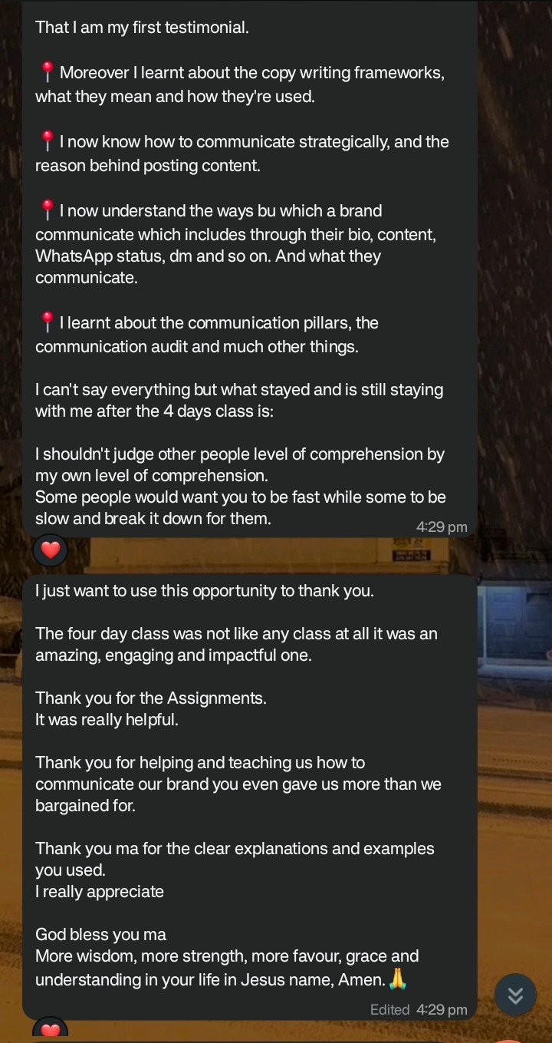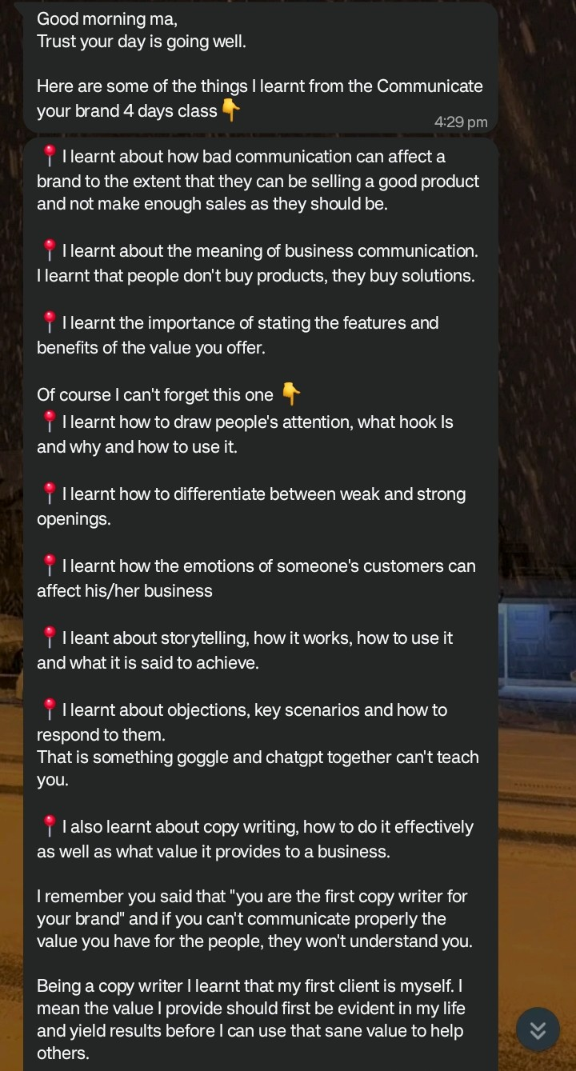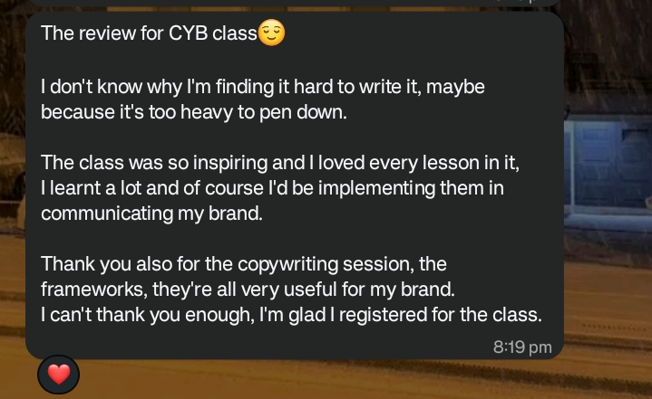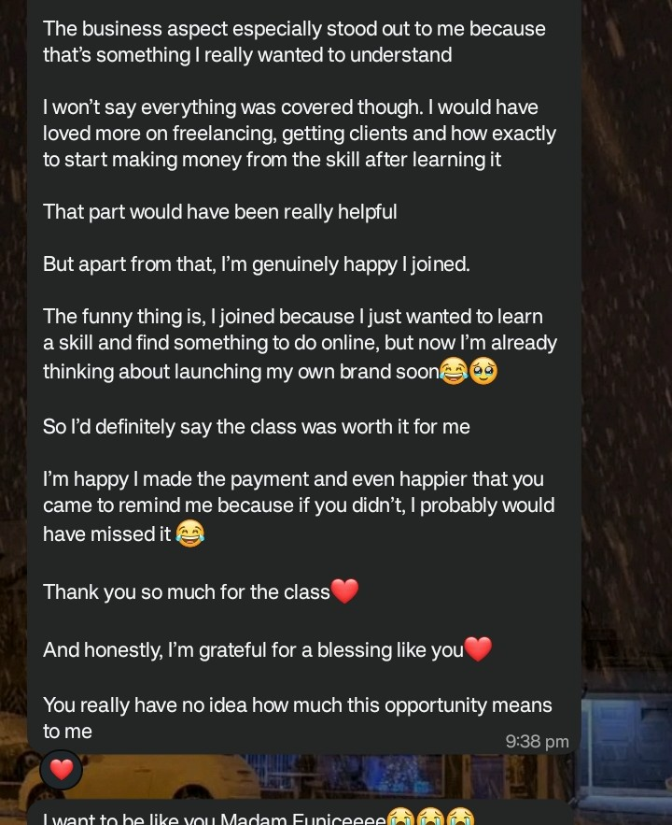

TEDx MOWE

Event & Partnership Support

Experience across event coordination, stakeholder communication, meeting management and partnership-related initiatives within the TEDx Mowe ecosystem.

Event Operations · Communication · Partnerships · Coordination

CAMPUS HIVE

Business Development

Part of the team driving business development initiatives for Campus Hive.

My role sits around identifying opportunities, developing relationships and contributing to strategic growth.

Business Development · Partnerships · Strategic Communication

06 — HOW I THINK

IDEAS NEED SYSTEMS.

I believe creativity exists in everyone.

The difference is often not who has creativity and who doesn't.

It is what happens to that creativity after it appears.

An idea without structure remains an idea.

A vision without a system depends on motivation.

And motivation is unreliable.

A system gives an idea somewhere to go.

It creates a framework for consistency, development and execution.

That is why I am interested in more than inspiration.

I am interested in architecture.

How does the idea work?

What holds it together?

What makes it recognisable?

How does it communicate?

How does it survive beyond the person who created it?

How does it become something people can experience, remember and return to?

Creativity gives you possibility.

Strategy gives it direction.
Systems give it longevity.**

And identity gives people a reason to recognise it.

WRITING IS NOT DECORATION.

Writing is infrastructure.

It gives an idea language.

It gives a brand a voice.

It gives a story movement.

It gives people a way to understand what you are trying to build.

The right words don't merely describe the landmark. They help people navigate toward it.

07 — THE HUMAN BEHIND THE WORK

ME, OUTSIDE THE TITLES.

Samson Eunice is a creative professional, author, editor, writing coach, song writer, identity strategist and creative concept architect whose work sits at the intersection of creativity, communication, strategy and business.

She has authored and published three books, edited manuscripts, trained over 500 people in creative writing, developed educational programmes and worked across brand communication, publishing, community development, events and business development.

But the titles only tell you what I do.

They don't tell you why I do it.

I'm deeply interested in ideas and the people behind them.

I'm interested in writing, creativity, songwriting, brands, psychology, storytelling, business, systems, people, education and the strange process through which something that exists only in someone's mind eventually becomes real.

Brands I've worked with
- HEWB (Headshot experience with Babalola
- Done Circle
- CampusHive
- Director Bim

08 — SOCIAL PROOF

THE WORK SPEAKS.

Testimonials:
Student feedback: Please, use the screenshot above for the students feedbacks in this place, you can place them here for me

Partnership feedback:
Miss Samson Eunice is someone who is always eager to work and willing to take on big steps.
She brings boldness, dedication, and a readiness to assist wherever she can.
Her willingness to put in the effort and contribute in different ways makes her a valuable part of the CampusHive team. ~CampusHive

I worked with Samson Eunice on the HEWB project, and I must commend her for her right attitude to work.
One of the most intriguing parts of working with her is her attention to detail, her ability to communicate what she wants in clear terms, and, most importantly, her attitude to work.
She’s a solid person to work with. ~Founder HEWB

Clients feedbacks:
You're too good, I can now access my brand voice without difficulties ~ Elora hair

You did an amazing job with our output, thank you so much ~Dylin Inn

Eunice has edited two of my books, and one thing I particularly appreciate about working with her is how well she retains my voice.
She knows when to correct, when to refine, and when to leave my words alone. That balance is rare in an editor.
I can trust her with my projects knowing that the final work will still sound like me, just better.
~Previous Oyinola

SO, WHAT ARE YOU BUILDING?

Maybe it's a brand.

Maybe it's a book.

Maybe it's a business.

Maybe it's a community.

Maybe it's a song.

Maybe it's an idea that hasn't found the right language yet.

Whatever it is, the first step is understanding what it could become.

Let's build from there.

START A CONVERSATION: samsoneunice123@gmail.com

© Copyright Samson Eunice

